Please feel free to copy, duplicate, and print the following
temperature logs, results logs, and recording logs and develop your own internal documents for your rapid testing program.

Rapid Testing Kit Storage Temperature Log
Thermometer location:

Rapid test kit brands monitored:

Acceptable temperature range: 8°C to 27°C (46°F to 80°F). Recommended to keep kits at room temperature.
Month/Year

Day | Temperature | Min | Max | Initials | Day | Temperature | Min | Max | Initials
1 |  |  |  |  | 17
2 |  |  |  |  | 18
3 |  |  |  |  | 19
4 |  |  |  |  | 20
5 |  |  |  |  | 21
6 |  |  |  |  | 22
7 |  |  |  |  | 23
8 |  |  |  |  | 24
9 |  |  |  |  | 25
10 |  |  |  |  | 26
11 |  |  |  |  | 27
12 |  |  |  |  | 28
13 |  |  |  |  | 29
14 |  |  |  |  | 30
15 |  |  |  |  | 31
16

NOTE: Periodically (e.g., every six months) check thermometer performance and document. Min/Max thermometers maintain a record of the highest and lowest temperature recorded during an observation period and are highly recommended.

Kits should be checked at least once a week with a preference to daily monitoring. Weekly monitoring should be performed with a min/max thermometer in place.

Corrective Action
Date | Action Taken | Initials

Reviewed by: | Date:

Rapid Testing Control Storage Temperature Log
Thermometer location:

Rapid test kit brands monitored:

Acceptable temperature range: 2°C to 8°C (35°F to 46°F)

Month/Year

Day | Temperature | Min | Max | Initials | Day | Temperature | Min | Max | Initials
1 |  |  |  |  | 17
2 |  |  |  |  | 18
3 |  |  |  |  | 19
4 |  |  |  |  | 20
5 |  |  |  |  | 21
6 |  |  |  |  | 22
7 |  |  |  |  | 23
8 |  |  |  |  | 24
9 |  |  |  |  | 25
10 |  |  |  |  | 26
11 |  |  |  |  | 27
12 |  |  |  |  | 28
13 |  |  |  |  | 29
14 |  |  |  |  | 30
15 |  |  |  |  | 31
16

NOTE: Periodically (e.g., every six months) check thermometer performance and document.
Min/Max thermometers maintain a record of the highest and lowest temperature recorded during an observation period and are highly recommended.

Controls should be checked at least once a week with a preference to daily monitoring. Weekly monitoring should be performed with a min/max thermometer in place.

Corrective Action
Date | Action Taken | Initials

Reviewed by: | Date:

RAPID TEST KIT INVENTORY
(to be completed on the last business day of every month)
Agency Name:
Name of Staff:
Completed for (Month/Year):
Date Completed:
Brand Name | # Test Kits on Hand | Test Kits Expiration Date | # Controls on Hand | Controls Expiration Date
OraQuick HIV
Determine Combo
INSTI
Syphilis Health Check
OraQuick HCV
Indicate Other Brands Below:

Rapid Testing Team – 01/08/2020

Rapid Testing Kit Results Log
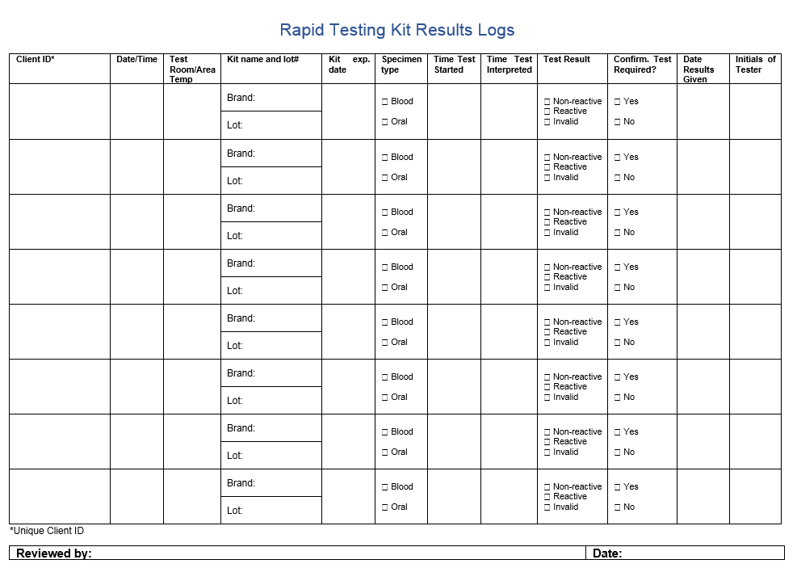
Rapid Testing Control Results Log
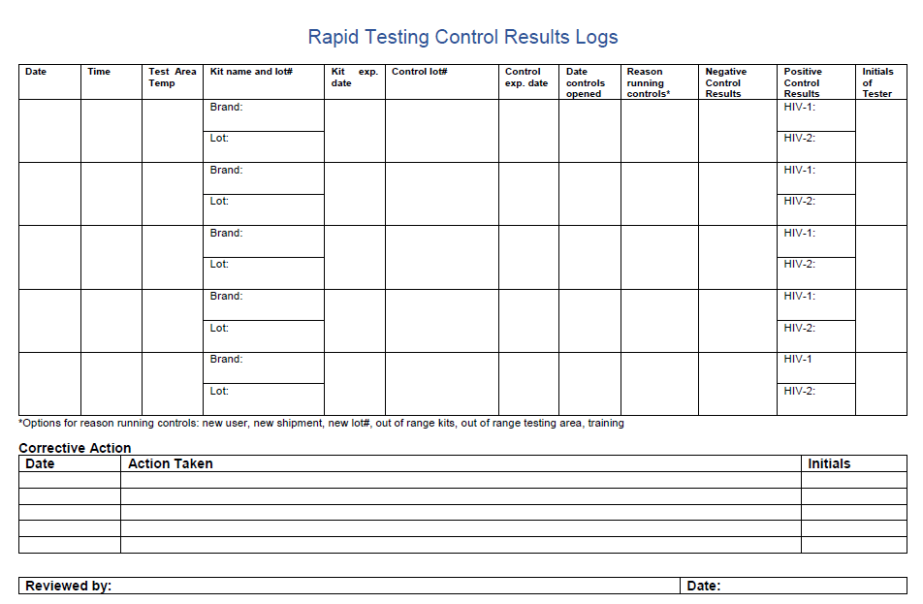
Example Rapid HIV Testing Training Records Log
Staff Member Name | OraQuick HIV/HCV | Determine Combo | INSTI | Syphilis Health Check | Whetstone | Safe Work Habits | Bloodborne Pathogens
 | Date:  Provided by:  - State  - Manufacturer  - Internal Agency  - Other | Date:  Provided by:  - State  - Manufacturer  - Internal Agency  - Other | Date:  Provided by:  - State  - Manufacturer  - Internal Agency  - Other | Date:  Provided by:  - State  - Manufacturer  - Internal Agency  - Other | Date:  Provided by:  - State  - Manufacturer  - Internal Agency  - Other | Date:  Provided by:  - State  - Manufacturer  - Internal Agency  - Other | Date:  Provided by:  - State  - Manufacturer  - Internal Agency  - Other
 | Date:  Provided by:  - State  - Manufacturer  - Internal Agency  - Other | Date:  Provided by:  - State  - Manufacturer  - Internal Agency  - Other | Date:  Provided by:  - State  - Manufacturer  - Internal Agency  - Other | Date:  Provided by:  - State  - Manufacturer  - Internal Agency  - Other | Date:  Provided by:  - State  - Manufacturer  - Internal Agency  - Other | Date:  Provided by:  - State  - Manufacturer  - Internal Agency  - Other | Date:  Provided by:  - State  - Manufacturer  - Internal Agency  - Other
 | Date:  Provided by:  - State  - Manufacturer  - Internal Agency  - Other | Date:  Provided by:  - State  - Manufacturer  - Internal Agency  - Other | Date:  Provided by:  - State  - Manufacturer  - Internal Agency  - Other | Date:  Provided by:  - State  - Manufacturer  - Internal Agency  - Other | Date:  Provided by:  - State  - Manufacturer  - Internal Agency  - Other | Date:  Provided by:  - State  - Manufacturer  - Internal Agency  - Other | Date:  Provided by:  - State  - Manufacturer  - Internal Agency  - Other
 | Date:  Provided by:  - State  - Manufacturer  - Internal Agency  - Other | Date:  Provided by:  - State  - Manufacturer  - Internal Agency  - Other | Date:  Provided by:  - State  - Manufacturer  - Internal Agency  - Other | Date:  Provided by:  - State  - Manufacturer  - Internal Agency  - Other | Date:  Provided by:  - State  - Manufacturer  - Internal Agency  - Other | Date:  Provided by:  - State  - Manufacturer  - Internal Agency  - Other | Date:  Provided by:  - State  - Manufacturer  - Internal Agency  - Other
Please list the name of each staff member who conducts rapid testing. Indicate the date of their most recent training and who provided the training. Keep a record of this document for internal use and update as needed. As different brands of rapid test kits come in, make sure to edit this internal template to reflect the current rapid test brand availability.

