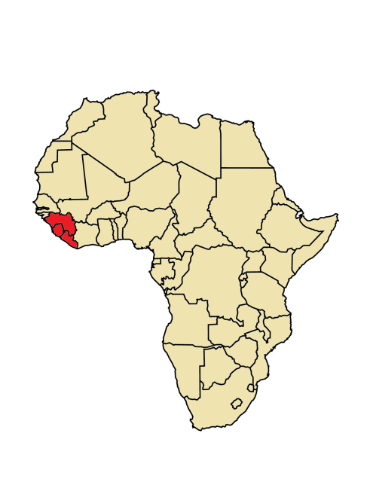
If you have been to Sierra Leone, Guinea, or Liberia in the past month, there is a possibility that you may have been exposed to Ebola
01/08/20154

What is Ebola? Ebola is the cause of a viral hemorrhagic fever disease. Symptoms include: fever, headache, joint and muscle aches, weakness, diarrhea, vomiting, stomach pain, lack of appetite and abnormal bleeding. Symptoms may appear anywhere from 2 to 21 days after exposure to Ebola virus, though 8-10 days is most common.

How does Ebola spread? You can only get Ebola from:
- Touching the blood or bodily fluids of a person who is sick with or has died from Ebola
- Touching contaminated objects, such as needles
- Touching infected primates or fruit bats

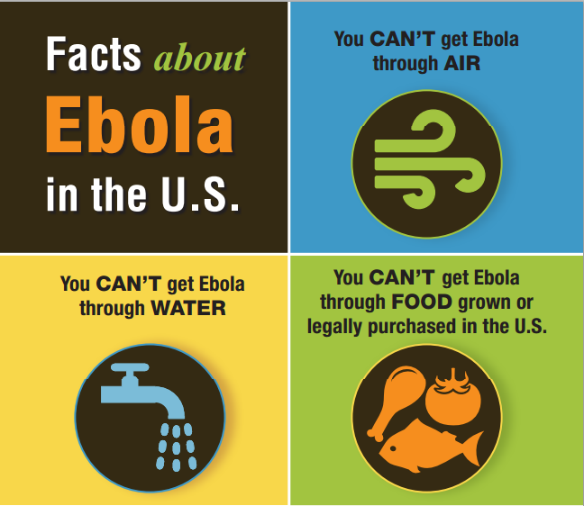

Ebola is NOT spread through air, water, or food produced in the U.S.

For more information:
www.ncdhhs.gov/ebola/
Enter your agency information/logos here
N.C. Ebola Public Information Line: 1-844-836-8714

North Carolina Public Health
NC Department
of Health and
Human Services

