INTERVIEW SCRIPT FOR PERSONS WITH SUSPECTED OR CONFIRMED COVID-19
For Coronavirus Disease 2019 (COVID-19) Contact Tracing
This document provides an outline of the steps and content to cover when interviewing someone believed or confirmed to have COVID-19. To jump to a particular section, click the hyperlinks below while holding the CTRL key on your keyboard:

Section 1: Preparing for the Interview 1
Section 2: Introducing Yourself and Purpose for Call 1
Section 3: Diagnosis, Symptoms and Medical History 4
Section 4: Isolation Guidance 9
Section 5: Needs Assessment for Resources or Support 10
Section 6: Treatments for COVID-19 11
Section 7: Wrapping Up 12
Section 8: Supplemental Questions about Locations and Activities Addendum 13
Section 9: Supplemental Questions About Travel Addendum 18
Section 10: Supplemental COVID-19 Vaccine Information 20

Section 1: Preparing for the Interview
Case Information – interview preparation within NC COVID  - Case patient’s name, date of birth,* county of residence (Demographics section)  - Date and location of specimen collection (Lab results tab)  Isolation Guidance – ensure you are up to date on COVID-19 isolation guidance**  COVID-19 Vaccine Information – ensure you are up to date on COVID-19 vaccine guidance, recommendations, and how to talk to contacts and case patients about barriers and vaccine hesitancies*** | This procedure is done prior to calling the case patient. Information is obtained from positive lab report.  *Take note if this person is a minor. See script sections below for “Minors Under 13” and “Minors Above 13, but Under 18.”  **Review current isolation guidance at the following link: Isolation and Precautions for People with COVID-19 | CDC and ensure you understand how it applies to your local health department guidance.  ***Review the Supplemental COVID-19 Vaccine Information

Section 2: Introducing Yourself and Purpose for Call
- IF THERE IS A RESPONSE:  “Hello, my name is [insert your name] and I am calling on behalf of the [insert name of local health department] regarding a time-sensitive public health matter. May I speak with [insert case patient’s first name]?”  - IF THERE IS NO RESPONSE (VOICEMAIL SCRIPT):  “Hello, this is [insert your name] calling for [insert case patient’s first name] on behalf of [insert name of local health department]. We are reaching out about a time-sensitive public health matter and would like to speak with you to provide some further information. Proceed appropriately with an option below.  IF LHD: At your earliest convenience, please give us a call back at the [insert name of local health department] at [insert phone number] or at our statewide call center at (844) 628-7223. Their hours are 8am to 6pm. Again, I am [insert your name] calling on behalf of the [insert name of local health department] regarding a time-sensitive public health matter. Thank you.”  IF CCTC: At your earliest convenience, please give us a call back through the statewide call center at (844) 628-7223 between 8am to 6pm, and ask for me, [insert your name], at extension [insert ext. number]. Again, the number for the call center is (844) 628-7223, and I am [insert your name] calling on behalf of the [insert name of local health department] regarding a time-sensitive public health matter. Thank you.” | If the person is not the individual you were trying to reach, ask to speak with the correct person. If the number is wrong, apologize for the inconvenience and end the call.
- ESTABLISHING PREFERRED LANGUAGE:  “Could I please confirm, is English your preferred language?”  IF ENGLISH IS CASE PATIENT’S PREFERRED LANGUAGE:  - “Thank you. And is this the best phone number to reach you?”  - IF ENGLISH IS NOT THE CASE PATIENT’S PREFERRED LANGUAGE:  “I’d like for you to be able to speak to someone in the language in which you are most comfortable speaking. May I call you back in just a few minutes with someone who can help us with that?”* | *If the case patient confirms that English is not their preferred language, continue according to regional or local health department direction. If the person cannot understand you, enunciate and convey in simple language that someone will call them back.
- IF THE CASE PATIENT IS NOT AVAILABLE TO TALK:  “Is there a better time for me to call back?” OR  “Sounds like this isn’t a good time for you. When would be a better time?” OR  “Sounds like you’re not feeling up to talking right now. Can you predict a better time?”* Pause for response and document.  “Or, if you would prefer, is there someone else who might be available who has your permission to speak to me about your illness?”** | The case patient might be sleeping, resting, or at work. Wait for a response, thank the person, document, and schedule an outreach for the designated time.  *If you need to call back later, document the requested time to call the case patient back and set a calendar reminder to call back.  **If the case patient provides a proxy, document the name of the person with whom you are speaking and that person’s relationship to the case patient.
- IF THE CASE PATIENT TRIES TO END THE CONVERSATION BY SAYING THEY ARE VACCINATED:  IF case patient voluntarily informs you that they have been  vaccinated, thank them for sharing and let them know you may have some more information to share that may help while they are navigating through this challenging time.  IF case patient questions why they tested positive for COVID-19 even though vaccinated, share the information listed to the right. | - Breakthrough infections are much more likely with the new Omicron strain of COVID-19  - Person could have already been incubating virus at time of vaccination.  - Vaccines are highly effective, but a small percentage of individuals do not develop the expected antibody response to vaccines.  - Vaccines may decrease severity of illness without preventing all infections.  Keep in mind this individual may not be fully vaccinated or may be eligible for a booster shot.
- IF THE CASE PATIENT IS AVAILABLE:  “Would it be all right if I asked you a few questions? Please know that any information you give me during our conversation is confidential. The same is true for any information that provided to the local health department.”  “Would you mind verifying your address and date of birth, so I can ensure that I have the right person on the phone, and that the right person’s information is pulled up in my system?”*  “Thank you for verifying your information. Again, please know our conversation is confidential. It might be best for us to speak in private. Are you somewhere where this is possible? Pause for response. I can give you a moment if you need to go somewhere else to be comfortable.” | *You can verify the person’s identity using any identifying information available in NC COVID. If the case patient is reluctant to confirm identity, encourage them to Google the number from which you are calling and see that it is legitimate; to call back to the call center (844-628-7223) between 8am to 6pm and listen to the automated prompt; or (as a last resort) to call the LHD to confirm the call is legitimate. If the case-patient is ultimately unwilling or unable to confirm their identity, the call cannot continue. Do not mention that you are calling about a COVID-19 diagnosis unless the identity has been confirmed.  If you do not currently have demographic information (i.e., you are not verifying this information but requesting it), it may be appropriate to wait until later in the conversation to request this information so that you can establish trust first.
- MINORS - UNDER AGE 13:  - “Hello, my name is [insert your name] and I am calling on behalf of the [insert name of local health department] regarding a time-sensitive public health matter. May I speak with your legal guardian?” | Must speak first to guardian.  Wait for guardian before continuing with call.
- MINORS - ABOVE AGE 13, BUT UNDER AGE 18:  IF case patient answers: “Since you are under age 18, I will need to speak to your legal guardian first. Would you please put them on the phone?”  IF adult answers: “Hello, my name is [insert your name]. May I speak with [name of case patient]’s legal guardian?” Pause for response.  “I have a few questions for your child to help understand their risk of becoming ill and to provide you some information and resources if needed. Would it be okay with you if I spoke with them directly or would you prefer to stay on the line?” Pause for response. | Must speak first to guardian. Ask permission to speak with minor.  If no guardian is available, ask if there is a better time to call back or a better number to use.  If the guardian answers the phone, continue with the call.
- IF CASE PATIENT IS OUT OF JURISDICTION:  If case patient is a NC resident, follow LHD’s protocol. Complete the interview then assign to the county of residence. Tell the case patient that we will send their information to their county of residence. Within the Administrative Package section of NC COVID, review Reason for Reassignment and click “LHD to LHD transfer.”  If case patient is not a NC resident, confirm state of residence, thank the case patient, and conclude the call. Within the Administrative Package section of NC COVID, select “Assign to the State” and include the reason.  If case patient is an out-of-state worker or a visitor in NC*, follow LHD’s protocol. Complete interview and document the location in NC where they are isolating. Once isolation is complete, visit the Administrative Package section of NC COVID, select “Assign to the State,” and include the reason. | Follow the out-of-state/OOJ guidelines. Ask for their home county and state.  *If the case patient is a student in school/college, they should be treated as NC resident

Section 3: Diagnosis, Symptoms and Medical History
“I am calling today because we are closely monitoring the spread of COVID-19. We understand that you have recently been diagnosed with COVID-19. I have noted here in our system that you were tested on [insert test date], and the facility that tested you is [insert the name of the facility]. Is this correct?” | You can find this information in the lab section of the NC COVID system. Someone with a positive antigen test is likely a positive case and they should begin isolation. They may seek confirmation with a PCR test.
“What can you tell me about your recent COVID-19 diagnosis?” | Wait for response. Listen carefully, reflect, ask case patient to elaborate, and summarize as appropriate. The case patient may convey valuable information about the symptoms that caused them to seek medical care, or alert you to exposures that inspired them to get tested.
“Has your medical provider provided you with any information or advice?”  “CDC guidance is changing quickly as more information becomes available about this new virus. We will discuss a little bit later some of the updated guidance.” | Wait for them to respond. Listen carefully, reflect, ask case patient to elaborate, and summarize as appropriate. This may help confirm a symptom onset date or discern if the case patient has been provided with inaccurate guidance.
“I would now like to ask you for some additional information to better understand your illness and provide you with the appropriate public health guidance to support not only your health but also that of your family and community. Do you have time for me to ask you some questions?” | Pause for response.
“Would it be okay if I asked you a few more questions about your medical history?”  “Do you have any medical conditions that would cause your immune system to be weakened or compromised?”* | Pause for response.  *Go through the list of conditions on the NC COVID Part II Form or local health department interview form. Be SPECIFIC and use plain language to ensure the case patient's understanding. (For example, instead of hematologic disorders, name specific diagnoses such as anemia (which can be clarified as “low iron”), sickle cell anemia, etc.)
IF CASE PATIENT HAS NOT YET PROVIDED THIS RESPONSE: “What was the reason for your COVID-19 test?” Listen carefully to case patient’s response; document thoroughly.  IF CASE PATIENT SOUGHT CARE DUE TO SYMPTOMS: “Could you please tell me when your symptoms started?” Wait for a response – reflect, ask for elaboration, or summarize as appropriate. Then, proceed with the following question if you have not yet received an answer.  “When you became sick, did you seek medical attention? Pause for response and document.  Where did you go?” Pause for response and document. | When case patient confirms that they are ready and begin to speak, start marking off the symptoms they mention. Then, ask about any remaining symptoms from the NC COVID Part II Form that they did not cover.  You will want to discern the date of onset for each symptom and ask for more details, such as the history or severity and any improvement/resolution. (When it began; when it worsened; if/when it improved; if/when it went away.)  If case patient is asymptomatic, review symptoms quickly to ensure that they know what they should watch out for, and report back if anything changes.
“Between [insert date 14 days before symptom onset date or test date] and [insert date of symptom onset date or test date] did you travel outside of your county?”  IF YES: “Could you please tell me a little more about that?” Pause for response. “What was your mode of travel?” Pause for response and document. Request additional details based on mode of transportation (plane, ferry, etc.) as listed in Travel Addendum below and document any additional notes. | Listen carefully to the case patient’s response, and document thoroughly. If the case patient does not provide the answers to any of the questions you need, prompt them accordingly. Where did they go? When did they go? With whom? How did they travel (car, air, etc.)?
“Can you tell me a little more about your living situation between [insert date 14 days before symptom onset date or test date] and [insert date of symptom onset date or test date]?  Further questions: "How many people live with you?" Pause for response and document. "What is their relation to you?" Pause for response and document. "Was anyone staying with you during this time period?" Pause for response and document. | Wait for them to respond; listen carefully; reflect; then ask them to elaborate or summarize as appropriate. This may help identify close contacts or could reveal a resource need pertaining to household members. Document thoroughly.
- IF THE CASE PATIENT REPORTS LIVING OR HAVING LIVED IN A CONGREGATE FACILITY:  Document as much information as you can gather about the facility, including:  - Where is the facility located?  - When was the case patient there?  - Who is their point of contact at the facility?  - Does the case patient know of anyone else that had tested positive or were showing symptoms in the facility? | Obtain answers to all related questions from the list on the NC COVID Part II Form by listening carefully to the case patient’s response, and then guiding them towards any missing information. Remember to pause between questions, allowing the case patient to elaborate. If the case patient reports living or having lived in a congregate facility, inform your regional leadership (LHD or CCTC) that you are following a case who has lived within a congregate setting.
- POTENTIAL MEDICAL FACILITY EXPOSURES:  “Other than what we’ve already discussed, between [insert date 14 days before symptom onset date or test date] and [insert date of symptom onset date or test date] did you have any need to seek medical attention or attend appointments at any healthcare facilities?” Pause for response and document. Prompt for more information if necessary. “The medical attention or medical exposure does not have to be related. You may have been in the hospital for a surgery, or a doctor’s office for a checkup that were not explicitly COVID-related.”  “Did you work at or visit any healthcare facilities?” | Obtain answers to all related questions from the list on the NC COVID Part II Form by listening carefully to the case patient’s response then guiding them towards any missing information. If the case patient reports that they have a potential medical facility exposure, inform your regional leadership that you are following a case who has worked in or visited a healthcare facility.
- POTENTIAL HIGH-RISK SETTING EXPOSURES:  "What are the top three places you think you were exposed to COVID?"  “Similarly, within the same time period, can you think about any times you may have gotten together for a meal or gathering with other family members or people outside your household?”  “Have you attended any celebrations, fairs, concerts, or religious events with people outside your household recently?”  “Do you have any children living in your home who are attending childcare, camps, school, or college?”  “Can you tell me more about your work situation?” Pause for response and document. “Do you work or volunteer in a childcare setting or school?”  “Can you tell me where you work and what your job title is?”  “Can you tell me more about the various roles in your organization?”  “What is the vaccination policy for students, faculty, and staff?”  If you discover that an individual participated in an event of interest (attendance at a restaurant/business, congregate facility, school, party, healthcare facility, sport/recreation, university, etc.), see the Supplemental Questions about Locations and Activities Addendum at the bottom of this document for follow-up questions. | Obtain answers to all related questions from the list on the NC COVID Part II Form by listening carefully to the case patient’s response then guiding them towards any missing information.  The following items are most important for understanding and controlling clusters and outbreaks:  - Employer/Occupation  - Attendance at a childcare, school, or university  - Travel history  - Live or work in congregate setting (nursing home, assisted living, group home, homeless shelter, migrant farm camp)  - Attendance at any crowded setting (e.g., party, church, gym, community event)  For further guidance on questions for establishments and activities, refer to the Supplemental Questions about Locations and Activities Addendum below. If the case patient reports that they have a potential high-risk setting exposure, inform your regional leadership (LHD or CCTC) that you are following a case who has worked in or visited a high-risk setting.
“OTHER EXPOSURES” section within NC COVID Part II Form  “Between [insert date 14 days before symptom onset date or test date] and [insert date of symptom onset date or test date]), did you/were you...”*  Document as much information as you can gather about the exposure, including:  - “Where is the place located?”  - “When were you there?” (date and time)  - “Do you know of anyone else who has tested positive or are now showing symptoms who were also there?” | 14 days (about two weeks)  *Obtain answers to all questions from the list under the ‘OTHER EXPOSURES’ section within the NC COVID Part II Form by listening carefully to the case patient’s response then guiding them towards any missing information.
- GATHERING CONTACTS  “You may have received a text or email inviting you to enter contacts through an online portal. Did you enter any contacts through this link?”*  Examples of questions to elicit contacts: “You mentioned earlier that you went to [insert location, occasion, or event]. Would you tell me a little more about that?” or…  “Would you please tell me more about [insert occasion or event]/the gathering at [insert location]? Pause for response and document. “Would you tell me who else was there?”  “Thank you for sharing that information. We want to make sure we are thinking of all the places where anyone may have been exposed. If you only think about [insert date 2 days before symptom onset or test date] and today – can you remember anywhere else you might have been in close contact with other people? This would be the period during which you were contagious and might have exposed anyone who was within six feet of you for 15 minutes or more. These 15 minutes are cumulative over a 24-hour period, so an exposure doesn’t necessarily have to be all at once.”  IF CASE IS HESITANT OR DOES NOT HAVE THE TIME TO PROVIDE CONTACTS: “I completely understand. We do have a secure website designed by the state of North Carolina Department of Health where you could enter this information directly in our database, and your contacts would get a text or email from us letting them know that we’re available to help. Everything you submit in this website is completely confidential, so even your close contacts will not be able to tell that you were the one who submitted their information. Is that something you’d be interested in? I am happy to help walk you through it, if so.”*  Informational questions:  - Contact’s First and Last Name  - Contact’s Employer and Job Title (if known)  - Contact’s Email (if known)**  - Contact’s Mobile Phone number**  - Contact’s Date of Birth or Age (if known)  - Contact’s Home Address including city or county of residence (if known)**  - What type of contact is this?  - Household member  - Intimate partner  - Work (name of workspace)  - Other_____________  - Does the contact work in a healthcare facility (e.g., hospital, medical clinic, nursing home, etc.)?  - Does the contact work in or attend daycare, school, or summer camp?  - What, if anything, would make it hard for this person to socially distance (for example they are in a setting like a shelter or substance use rehabilitation center or jail/prison, etc.)?  - What was the last day you had contact with this individual?  - In what language does the contact prefer to communicate? | *NOTES ABOUT THE CASE PATIENT PORTAL:  - Before your interview, it is possible your case patient may have already provided contacts through the portal. If you work in CCTO, review and verify this information per the job aid.  - During your interview, ensure you acknowledge any contacts your case has submitted and verify this information if needed. If you receive new information about a contact already submitted through the portal, ensure the existing CCTO monitoring event is updated appropriately.  - During and after your interview, encourage the case patient to use the portal as much as needed to review resources, see their isolation guidance, and provide contacts. For more information, please see the Understanding the Case Portal Job Aid for the case patient’s perspective and the Case Portal Guidance - CIs for a recap of what they can provide in this portal.  Wait for them to respond; listen carefully; reflect, then ask them to elaborate or summarize as appropriate.  It is okay if the case patient cannot or does not want to answer some of the questions, but if you explain before you start why it is important to get as much information as possible, they will be more likely to cooperate. E.g.:  “Because the more we know about where you work, and with whom you live and socialize, the better we can understand where you might have gotten COVID-19, and who else might be at risk for the illness. Even if you have already reached out to your co-workers, friends, and family to inform them that they have been exposed, our database can identify linkages between people that no individual can detect, allowing health departments to find outbreaks that might otherwise go undetected.”  **Without a phone number, a complete mailing address, or an email address, it is impossible for a contact tracer to reach out to anyone. Make sure you get at least one of these forms of contact information.  For guidance for contacts, please see:  https://www.cdc.gov/coronavirus/2019-ncov/your-health/quarantine-isolation.html  If an individual is a household contact and unable to isolate, the last day of exposure to the case patient will be the last date of their isolation period (day 5, unless extended due to symptoms). (Isolation requires not sharing a bedroom, bathroom, or shared spaces with anyone else. If that is not possible, it requires disinfecting (cleaning) those areas after each use.)

Section 4: Isolation Guidance
- IF CASE PATIENT IS SYMPTOMATIC:  “According to the day on which your symptoms started, your isolation period should be through at least [insert 5 days from symptom onset date], provided you are feeling better. This means you can leave your home on [insert 6 days from symptom onset date] if it has been 24 hours since you have had a fever without the use of any fever reducing medications and your symptoms have improved. If you leave your home after your isolation period ends, you should wear a mask around others until [insert 10 days from symptom onset date], and you should avoid people who are immunocompromised or at high risk for severe disease, and nursing homes and other high-risk settings. You may be able to remove your mask before this date by using antigen tests (eg. At-home tests) and receiving two negative tests after your isolation ends, each 48 hours apart. If you become severely ill or are unable to wear a mask around others, you should isolate until at least [insert 10 days from symptom onset date].” See isolation guidance on the right.*  - IF CASE PATIENT IS ASYMPTOMATIC:  “According to the day on which you tested positive for COVID-19, your isolation period should be through at least[insert 5 days from date of test]. This means you can leave your home on [insert 6 days from date of test], but you must wear a mask around others until [insert 10 days from test date]. You may be able to remove your mask before this date by using antigen tests (eg. At-home tests) and receiving two negative tests after your isolation ends, each 48 hours apart. If you develop any symptoms, you will need to ensure that it has been 24 hours since you have had a fever off all fever reducing medications and that your symptoms have improved before you can leave isolation.” See isolation guidance on the right.*  IF CASE PATIENT IS IMMUNOCOMPROMISED:  “Your isolation period should have begun on [insert date of symptom onset or test date if asymptomatic] and will continue through at least [insert 10 insert days from symptom onset or test date if asymptomatic]. You will need to ensure that it has been 24 hours since you have had a fever off all fever reducing medications and that your symptoms have improved before you can leave isolation. Since you are immunocompromised, you may need to isolate for up to an additional 10 days. You should consult with your healthcare provider about when you can resume being around other people.” See isolation guidance on the right.*  IF CASE PATIENT IS IN A HIGH-RISK CONGREGATE SETTING:**  “Your isolation period should have begun on [insert date of symptom onset or test date] and will continue through at least [insert 10 days from symptom onset or test date.] You will need to ensure that it has been 24 hours since you have had a fever off all fever reducing medications and that your symptoms have improved before you can leave isolation. You should consult your facility guidelines about when you can resume being around other people.” See isolation guidance on the right.* | The case patient should be aware of the criteria necessary to leave isolation. If criteria are not met, the isolation period should be extended.  Symptomatic Requirements to End Isolation:  - It has been at least 5 days since the day after symptoms first began 24 hours without a fever (without fever-reducing medications such as Tylenol, Ibuprofen, Advil, Naproxen)  - Symptoms have improved  *Please check this link often to make sure you are up to date on guidance and ensure you understand how it applies to your local health department guidance.  Provide most recent isolation guidance based on the current CDC and NC DHHS guidance at the following link: COVID-19 Quarantine and Isolation | CDC  **For individuals working or living in a high-risk facility, the CDC recommends that these individuals isolate for 10 days.

Section 5: Needs Assessment for Resources or Support
“Next, if it is all right with you, I would like to ask you a series of questions about what kind of resources you might need if you do become ill, or how we may be able to assist you with some of the challenges of remaining in isolation.” | Pause for response.  (Find out if they have or need a thermometer. We do not offer medical advice. Refer case patient to the below contact information.)
“Would it be okay if I share with you some things others thought were helpful?”  “How will you approach staying home from work, or working from home, during your isolation period?”  “Do you need a note for your employer about your need to stay home and isolate yourself?”*  “Do you have a stable and safe place in which you will feel comfortable for the duration of the isolation period?”  “Do you have someone who can bring you food and supplies if needed?”  “How will you approach isolating yourself within your home away from others in the household?”  “Do you have access to a phone or the internet?”  “Do you have any household members who are at higher risk for becoming severely ill if they acquire COVID-19?”*  “Do you have someone who would take care of you if you became ill?”  “Are there any other resources that you need to stay home safely for the duration of your stay home period?” | IF YES: Continue to share information. Pause at intervals to confirm, “Does that make sense?” And be sure to inquire, “Do you have any questions about what I just said?”  *If a work note is needed, follow local protocol for getting this to the case patient.  *(For example, age >64yrs, chronic medical conditions, immunosuppressed conditions.)  If case patient identifies resource needs that you can help resolve without needing to refer to the local health department (i.e., referral to 2-1-1 or NCCARE360), do so and document the resolution in the Notes section in the NC COVID system.  If the case patient identifies an urgent mental health resource need, defer to local guidance and your regional leadership (LHD or CCTC) for support.
If the case patient identifies a resource that you are not able to help them resolve, proceed with the following:  “You have identified a potential resource need that we want to make sure gets addressed. If we find we can meet this need locally, would it be okay for a representative from the local health department to follow up with you to discuss how we can provide you with the support you need?” | IF CASE PATIENT IS OPEN TO FOLLOW-UP – Refer to the appropriate local health department point of contact (POC) or regional leadership (LHD or CCTC) and document the identified resource need and referral to the local health department POC or regional leadership (LHD or CCTC) in the NC COVID Notes page on the dashboard.  IF CASE PATIENT DOES NOT WANT FOLLOW-UP - Provide the case patient with the local health department’s contact number and COVID-19 Call Center number (844-628-7223) and advise them to call if they need anything. Still notify the local health department’s POC or regional leadership (LHD or CCTC) of the case patient’s identified resource need but let them know the case patient has requested no assistance at this time.

Section 6: Treatments for COVID-19
“Next, I’d like to give you a little information about a few potential treatment options for COVID-19 that may help you feel better faster and could help prevent hospitalization. Would you be interested in hearing more?”  IF INTERESTED IN LEARNING MORE: “Currently, there are two main types of COVID-19 treatment options to use outside of a hospital setting in the United States. These treatment options include monoclonal antibody and oral antiviral treatments.  Monoclonal antibodies and oral antiviral treatments are medicines that fight the virus that causes COVID-19. Monoclonal antibodies can be given to you directly with an IV or a shot, while oral antivirals can be given to you in the form of an oral pill. These medications can be helpful for people who are at a higher risk for severe infection and hospitalization. The treatments are authorized for high-risk* individuals with COVID-19, which may include those over 65 years old or people with conditions like heart disease, diabetes, or anything that may result in a weakened immune system.  COVID-19 treatments do not replace the benefit of COVID-19 vaccines. Vaccines still provide the best protection against severe disease and death; however, these treatments are options that may prevent hospitalization for some patients if taken soon after symptoms start.  If you’d like to learn more about treatment, to discuss your eligibility, or simply to ask any questions you may have about treatment, you can speak to a healthcare provider, call our COVID-19 treatment call center (see right), or visit https://covid19.ncdhhs.gov/treatment.  Does all of that make sense?” (Pause for response).  “Thank you for speaking with me about these treatment options.”  IF NOT INTERESTED IN LEARNING MORE:  “Not a problem. If you would like to learn more at any time, you can visit https://covid19.ncdhhs.gov/treatment for information.” | For information and FAQs: https://covid19.ncdhhs.gov/treatment  To find a treatment location:  https://covid19.ncdhhs.gov/FindTreatment  For information about COVID-19 treatment, call:  - 1- 800-232-0233 (English & Spanish)  *Other examples of high-risk factors that may justify COVID-19 treatment may also include older age (>65), obesity, pregnancy, etc.

Section 7: Wrapping Up
“What other questions can I answer for you now?”  “If at any time your symptoms worsen, and you experience shortness of breath, your lips or fingertips are turning blue, you start feeling sleepy or sluggish, or if you have a fever of more than 102˚ Fahrenheit and it is not reducing, please call your medical provider or 911, and let them know you have COVID-19, so that they can provide immediate and appropriate care.”  “In order for me to provide you with the current vaccine guidelines and help keep you and your community safe, I’m curious – have you received the COVID-19 vaccine?”  - IF VACCINATED*:  - “Since you’ve been vaccinated, can you provide me with the dates you received each dose, and what type of vaccine?  - “Are there any questions I can answer or resources I can provide you to help the people around you who might not have been vaccinated yet?”  “A couple final things. Have you received the updated booster shot? You can find details on whether you are up to date on COVID-19 vaccines and boosters at the CDC website (see right), or you can also reach out to a healthcare provider or the Vaccines Call Center (888-675-4567) for any questions or concerns you may have regarding booster shots.”  - IF NOT VACCINATED**:  “Before we get off the phone, we at the [insert name of local health department] do want to reach out and let everyone in our area know that the COVID-19 vaccine is free, safe, and available to anyone who would like to receive it. Now that you have COVID-19, the CDC (Centers for Disease Control) recommends you receive the vaccine once you have recovered from COVID-19 and your isolation period has ended because this will help reduce your risk of getting infected again by more than half. I’m curious; what are your thoughts on the vaccine(s)?” Pause for response. Refer to Supplemental COVID-19 Vaccine Information  - CLOSING THE CALL:  “If you think of any questions after this call has ended, you can contact [insert name of local health department] at [insert the local health department’s phone number] or the NC COVID Community Team Call Center at (844-628-7223) between 8am to 6pm. My extension is [insert your extension], and once again my name is [insert your name].”  “Thank you for your time today and for answering my questions. We are here to help so please do not hesitate to reach out with any questions during this challenging time.” | Allow the case patient to respond; answer accordingly.  Have the case patient repeat the symptoms you have listed and need to monitor.  *If case patient confirms they are fully vaccinated and still tested positive for COVID-19, complete the interview, provide isolation guidance and information about boosters, and report the breakthrough case in accordance with the local health department's guidelines, and they will determine if the case needs to be reported to NC DHHS (Department of Health and Human Services) based on their latest guidance.  Reasons a fully vaccinated person might test positive:  • Breakthrough infections are much more likely with the current Omicron strain of COVID-19  • Person could have already been incubating virus at time of vaccination.  • Vaccines are highly effective, but a small percentage of individuals do not develop the expected antibody response to vaccines.  • Vaccines may act by decreasing severity of illness while not preventing all infections.  If case patient has been vaccinated, enter the information in the vaccination section of NC COVID.  CDC website on booster shot information: https://www.cdc.gov/coronavirus/2019-ncov/vaccines/booster-shot.html  CDC guidelines now allow for “mix and match” dosing of booster shots, meaning that individuals may choose which vaccine they receive as a booster shot, regardless of what was previously received. If the contact asks you about this, please tell them to speak with their provider. More information can be found here: https://www.cdc.gov/coronavirus/2019-ncov/vaccines/stay-up-to-date.html  **If they have not been vaccinated, listen and reflect on their response. If they are willing to discuss more with you, continue to the Supplemental COVID-19 Vaccine Information when you finish your conversation.  IF you are monitoring this case patient within CCTO, vaccine referrals should be documented (per the Referrals job aid) for every case and contact who is monitored in CCTO, even if they are fully vaccinated or decline the referral. Vaccinated individuals may also be interested in offering resources to others in their family or community and therefore may be interested in the referral or in receiving further vaccine communications.

Section 8: Supplemental Questions about Locations and Activities Addendum
CONGREGATE LIVING FACILITIES  - “Can you tell me more about the roles in your organization?”  - “What is the shift structure in your facility?”  - “Can you tell me more about the number of staff members on shift at any given time?”  - “How many residents does your facility accommodate?”  - “When do you think the outbreak started?”  - “How did the disease start to spread?”  - “Can you tell me more about the reported exposures?  What kind of testing protocols does the facility have in place?”  - “What type of social distancing protocols do you have in place?”  - “Can you share more about how is your facility is divided/arranged? Sleeping? Meals? Showers?"  - “Are there any other possible exposures to or by visitors, or staff?”  - “How many staff and other residents are at this facility?”  - “How does the facility handle isolation and quarantine?”  - “What measures have you implemented to prevent further spread of COVID-19?”  - "Was the local health department informed of the exposures?" | This includes types of congregate living facilities not identified elsewhere including migrant farms, homeless shelters, group homes, treatment centers – substance abuse, mental health, etc.  Staff or residents may have specific knowledge as to how they believe it started. Prior exposure to COVID positive person within the previous 14 days?
CORRECTIONAL FACILITIES
- “Based on these onset dates, when do you think the outbreak started?”  - “How do you think the disease started to spread?”  - “What measures have you implemented to prevent further spread of COVID-19?”  - “Can you tell me more about the reported exposures?  What kind of testing protocols does the facility have in place?”  - “Are there any other possible exposures to or by visitors, staff, or inmates?”  - “What are the visiting hours structured?”  - “What type of social distancing protocols do you have for visits?”  - “Can you share more about how your facility is divided?”  - “How many total inmates, faculty and other staff are at the jail?”  - “How does the facility handle isolation and quarantine?”  - "Was the local health department informed of the exposures?" | Staff or residents may have specific knowledge as to how they believe it started.
DAY CARE/K-12

- "How many classrooms does the institution have?"
- "Do students/teachers ever change classrooms?"
- "How many students are in the classroom at a given time?"
- "How many teachers are in the classroom?"
- "Can you tell me more about the school's organized transportation and mode of travel for staff?"
- "What process do you have in place for mealtimes, recess, and bathroom breaks?"
- "What kind of afterschool activities or group events are in place?" If so, “What are they?”
- "What actions have the educational institution already taken?"
- "Was social distancing/masking in place?"
- "What type of communications were delivered to individuals who had close contact with positive cases?"
- "Was the local health department informed of the exposures?"
HEALTH CARE FACILITIES  - "What type of facility is it?"  - "Is it an inpatient or outpatient facility?"  - "Is it a congregated facility?" If so, "How many rooms does the facility have?"  - "Are they allowing visitors or other outside healthcare providers?"  - "Was social distancing/masking in place?"  - "What arrangements are in place for meal distribution?"  - "What type of communications were delivered to patients and family members who had close contact with positive cases?"  - "How are they isolating positive cases from the rest of the facility?"  - "What department/halls were exposed?"  - "What actions have the health care institutions taken to protect residents and visitors?"  - "Was the local health department informed of the exposures?" | Possible types of facilities:  Alternate Care Sites  Ambulatory Care Settings  Assisted Living Facilities  Blood and Plasma Facilities  Dental Settings  Dialysis Facilities  Nursing Homes and Long-Term Care Facilities  Pharmacies
PARTIES/SOCIAL GATHERINGS  - “How many people attended the party or gathering?”  - “Can you tell me more about the setting of the gathering?”  (location, inside, outside, both, etc.?)  - “Was everyone wearing a mask?”  - “What kind of social distancing or precautions are/were in place?”  - “Were the people at the party compliant with the protocols?”  - “Was there any food or drinks served at the gathering?”  - “What measures did you take to inform the guest(s) of exposure(s)?”  - “Have you held or attended any other gatherings in the last two weeks?” | Attendees may have specific knowledge as to how they believe it started. Prior exposure to COVID positive person within the previous 14 days?  Collect names and phone numbers of all guests.
PLACES OF WORSHIP  - “What do you know about the cluster or outbreak in your place of worship?”  - “Can you tell me more about the exposures?”*  - “About how many people attended the service(s)?”  - “Was there a choir or other singing during the event?”  - “Does the location keep a list of congregants or attendees for their services? “  - “How many contacts did the establishment collect?”  - “Tell me more about any actions the church leadership has already taken for member safety?”  - “How do leadership and congregation feel about vaccinations?”  - “Can you provide some guidance regarding how children are cared for during service?”  - “Was the local health department informed of the exposures?” | Keep in mind some religious groups do not support vaccines and other state guidance. Tread lightly, as we do not want them to shut us out. This will give us the opportunity to ask about vaccines, provide guidance, etc.  *Did the exposure occur at a service, small group event, or other community events?
SPORTS/RECREATIONAL ACTIVITIES  - “What sport does the team play?”*  - “What is the full name, age group, and level of the sports team?”  - “How many players are on the team?”  - “Can you tell me more about where the possible exposure occurred?”  - “What was the date(s) of the event?”  - “Can you tell me more about the sporting event?”  - IF game/scrimmage/tournament, “What other teams played?”  - “Did the exposure occur during a game, practice, tournament, or team social event?”  - “Was social distancing/masking occurring throughout the entire practice?”  - “Where was the exposure?”  - “Can you tell me who else was at the event?”  - “What actions have already been taken by the team officials?”  - “What were the modes of transportation to event?”  - “Were there any other travel accommodations?”  - “Was the local health department informed of the exposures?” | *Specific team name and age group required.  Considerations: water breaks, lacing up, bench time, small group skills/practices.
UNIVERSITIES/COLLEGES  - “What is the vaccination policy re: students, faculty and staff?”  - "What is the educational program?"  - "What kind of living arrangements are/were in place?"  - “Do they participate in any other school activities or teams?”  - “What activities?”  - “When was the last date they participated?”  - "Are there any other schoolmates, roommates, with symptoms or who have tested positive recently?"  - "How many classes do you have in common with the others who have been exposed?"  - "Were there any other events that could have been linked to this one?"  - "What arrangements do you have in place for meals?  - "What type of participation do you have in collegiate activities or events?"  - "What actions have already been taken by the educational institution?"  - "Was social distancing/masking in place?"  - "What type of communications were delivered to individuals who had close contact with positive cases?"  - "Was the local health department informed of the exposures?" | *Keep in mind that some universities/schools have a specific COVID Coordinator, Case Investigator or Contact Tracer Program that may have started their own investigation/protocols.  (Dorm? With roommates or at home?)  In a sorority or fraternity? May want to speak with Greek Advisor, Resident Advisor, or House Parents  - If they live in any of these university settings mentioned above, you will want to know:  - The address  - Room number  - House/Complex name  - If contact is made with a Dean, which programs were infected?  Did case patient stay or go anywhere else off-campus?

Section 9: Supplemental Questions About Travel Addendum
TRAVEL VIA AIRPLANE
- Country  - State  - City  - Dates  - Name of Airline  - Flight Numbers  - Cabin Numbers  - Seat Numbers | 14 days prior to onset, did the patient have any travel history?  How many planes did the CP take to get to and from destination?
TRAVEL VIA BOAT
- Country
- State
- City
- Dates
- Name of Ship or Ferry?
- Was it a cruise ship?
- Cabin Numbers
- Did they fly anywhere to get to the cruise ship? If so, go to Travel via Airplane section above.
- Did they stay in a hotel before boarding cruise ship? If so, go to Hotel Stay section below.
HOTEL STAY
- Name of Hotel
- Country
- State
- City
- Dates
- Room Number
BUS/Taxi/Shuttle/Train
- Name of Bus/Taxi/Shuttle/Train Servicer
- Country
- State
- City
- Dates
- Identification number of Bus/Taxi/Shuttle/Train
- Seat number if any
OTHER
Specify the following:
- Mode of transportation
- Country
- State
- City
- Dates
- Seat number if any

Section 10: Supplemental COVID-19 Vaccine Information
To make sure you have the most up to date CDC information and guidance regarding the COVID-19 vaccine, please refer to the following websites:
- Stay Up to Date with Vaccines
- How to talk about COVID-19 Vaccines
- Understanding how COVID-19 Vaccines Work
- CDC's Myths and Facts about COVID-19 Vaccines

Additional Resources
- Booster Tool (Find out when you or your loved one is due for their next shot!)
- Frequently Asked Questions about COVID-19 vaccines
- COVID-19 Data Tracker
- Chat online with a robot that can answer your COVID-19 vaccine questions
- To find vaccines near you, you can:
    - Visit myspot.nc.gov
    - Call 1-800-232-0233
    - Text your zip code to 438829

- There are four recommended COVID-19 vaccines in the U.S today
- The COVID-19 vaccine is free, safe, effective and recommended for everyone over 6 months old.
- Getting vaccinated is the best way for us to get back to normal and keep our community safe from severe illness/hospitalization due to COVID-19.

Basic COVID Vaccine Info

Have you received any COVID-19 vaccines so far?

Yes
No

That is not a problem. I respect your decision and am not here to push you at all. There can be a lot of different reasons why people are hesitant to get the vaccine. It is helpful for your Local Health Department to be aware of those different reasons, so that we can better understand our community. Would you feel comfortable telling me a little about your own reasons? I am here to listen, try to understand, and only offer information if you want it.

That is great news, thank you for letting me know! We will update our records to reflect the vaccines you have received and make sure that you are up to date with current recommendations.
Do you feel comfortable telling me a little more about the vaccines you have received and when, so I can update our records as well as learn if you are up-to-date?

Yes
Yes
No
Thank you for being willing to talk more with me about this. Which vaccine did you receive and when did you receive it? I can wait if you need to go get your vaccination card.
Vaccine Schedule for Non-immunocompromised Individuals
Vaccine Schedule for Immunocompromised Individuals

B

Thank you for being willing to talk more with me about this. Can you tell me more about your reasons to not get vaccinated?

That’s alright. I appreciate your time. If you do have any other questions later about the COVID-19 vaccines, feel free to call a health care provider you trust or your local health department.

Click below to find talking points on common vaccine hesitancy reasons:
- Cost  - Don’t need it (I’m healthy/ just had COVID)  - Don’t need it (nobody gets COVID anymore)  - Microchip/No govt. trust  - Safe for kids? | - Came out too fast (is it safe?)  - Does it work?  - I don’t know/something else  - Side effects  - Immunocompromised  - Pregnant/ Breastfeeding/ Fertility

Click if questioning whether to get a booster

Vaccine Hesitancy and Confidence Building Conversations
One of the primary vaccine barriers is vaccine hesitancy, a personal choice to delay or refuse getting vaccinated. When talking to contacts and cases, it may be helpful to understand some common reasons for hesitancy and how to engage in dialogue with those individuals. Some identified reasons and possible responses are listed below.

I’m worried about the cost of the vaccine.

- The COVID-19 vaccine is free for everyone! No proof of insurance or ID is required to receive the vaccine (NC DHHS).

I don’t think I need the COVID-19 vaccine. (Either) I’m young and healthy (or) I just recently had COVID-19 so now I have natural immunity, right?

- The Omicron variant is very contagious; anyone is susceptible to contracting the virus and possibly having symptoms. The virus can be spread by asymptomatic individuals (CDC).
- Re-infection can happen and new variants of the virus continue to be discovered (CDC).
- Individuals who have previously had COVID-19 infection are less likely to become reinfected if they are fully vaccinated (CDC).

I’m worried about the side effects of the vaccine.

- Some patients do experience mild side effects after receiving the vaccine. However, the possible side-effects are minor in comparison to the chance of you, or a loved one, contracting COVID-19 and becoming seriously ill (CDC)
- Side-effects do not include contracting COVID-19 or other serious health conditions (CDC)
- Research indicates that getting the vaccine is the best way to protect yourself from serious side effects, hospitalization and death due to COVID-19 (CDC)

I have a health condition and am concerned about my safety.

- If you have concerns about a specific health condition, you should consult your doctor.
- Individuals with moderate or severe immunocompromising medical conditions are at increased risk of becoming seriously ill or even dying from COVID-19, so getting vaccinated is especially important for these individuals (CDC).
- You can self-attest to your moderate or severe immunocompromised status. There is no paper documentation needed to receive a vaccine or booster (CDC).

No one is really getting COVID-19 anymore, so I don’t need the vaccine.
- People are still contracting COVID-19 across the state and country (CDC)
- The Omicron variant is even more contagious than the Delta variant (CDC)
- People that are unvaccinated account for the majority of hospitalizations and deaths due to COVID-19 (CDC)

I don’t want a microchip implanted in me. (or) I don’t trust the government.

- The COVID-19 vaccine doesn't contain any technology including microchips or software. All vaccine ingredients are publicly listed on the FDA and CDC websites. (CDC)
- The COVID-19 vaccines were not developed by the government, but rather by private companies with long-standing reputations for providing safe and effective vaccines. (CDC)

The vaccine was developed so quickly. I want to wait and see if it’s safe.

- The quick development of the vaccine was not due to any corner-cutting and followed the standard FDA approval process as every vaccine before (CDC).
- More than 619 million people have received a COVID-19 vaccine (CDC)
- Researchers had previously been studying coronaviruses for years and were able to get a head start in the development based on that research (CDC)
- To make sure the vaccine is safe, CDC expanded and strengthened its ability to monitor vaccine safety (CDC)

I am pregnant, breastfeeding or thinking of becoming pregnant in the near future and I have concerns about how the vaccine may affect me and/or my child.

- The vaccine is recommended for people who are pregnant, breastfeeding, or trying to get pregnant in the future. (CDC)
- People who get COVID during pregnancy are more likely to get very sick or have complications (CDC)
- Studies show that COVID-19 vaccination did not affect women’s likelihood to get pregnant (PubMed) or increase the risk of miscarriage (when vaccinated before 20 weeks) (CDC)
- If you would like to speak with someone about COVID-19 vaccination during pregnancy, you can contact MotherToBaby, whose experts are available to answer questions in English or Spanish by phone or chat. Call 1-866-626-6847 M-F, 8-5pm or go online to https://mothertobaby.org/askanexpert

- Vaccines for children are safe and effective. (CDC)
- Why Children And Teens Should Get Vaccinated (CDC)
- Children receive a smaller dose of the vaccine than teens or adults (CDC).
- Millions of Americans ages 5-17 have received the COVID-19 vaccine (American Academy of Pediatrics)
- 6 Things to Know About COVID Vaccination for Children (CDC)

Getting the vaccine for myself is one thing. Vaccinating my child is another thing. I’m too scared to risk it.

I don’t think the vaccine works.

- Unvaccinated adults were 5.3x more likely to be hospitalized due to COVID-19 than their up-to-date, vaccinated counterparts. (CDC)
- The COVID-19 vaccine has proven to be highly effective, cutting down on infection and hospitalization (CDC)

I don’t know why I don’t want to (or) it’s something else.

It’s okay. Your opinions are valid and at the end of the day, it is your decision whether or not to be vaccinated. I am here to support you. Do you have any questions for me?
Would it be alright with you if I share a little bit of information about the vaccine?
If yes, click here for basic information about the COVID-19 vaccine
If no, Thank you for your time and if you have any other questions you can call your local health department or health care provider.

I got my primary series but I am not up-to-date on all my boosters. Does it really matter?
That is great that you received the primary series of the COVID-19 vaccine! That will provide you some protection. However, the CDC recommends that everyone over the age of 5 receive the bivalent booster which helps protect against the Omicron variant specifically. Similar to the flu vaccine, it is important to receive regular booster shots because immunity wears off with time and new variants emerge that might not be as protected by a previous vaccine. Does that make sense?
Would you like to learn how to schedule your booster today?
If yes, click here
If no, thanks for your time. You can always call or go online later if you decide you want to.
Offer to give info if they want it:
1.) Visit myspot.nc.gov 2.) Call 1-800-232-0233 or 3.) Text zip code to 438829

Vaccine Schedule For People Who Are Not Immunocompromised
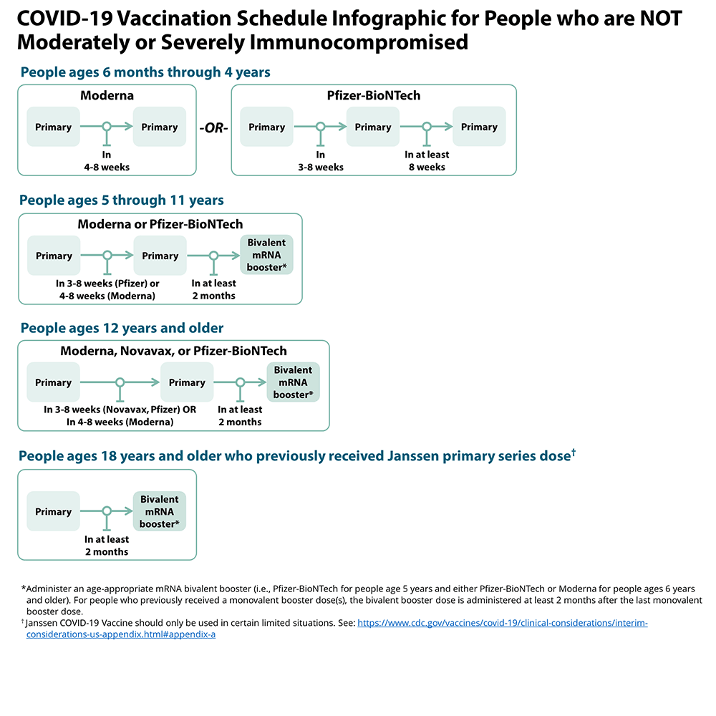

Vaccine Schedule For People Who Are Immunocompromised
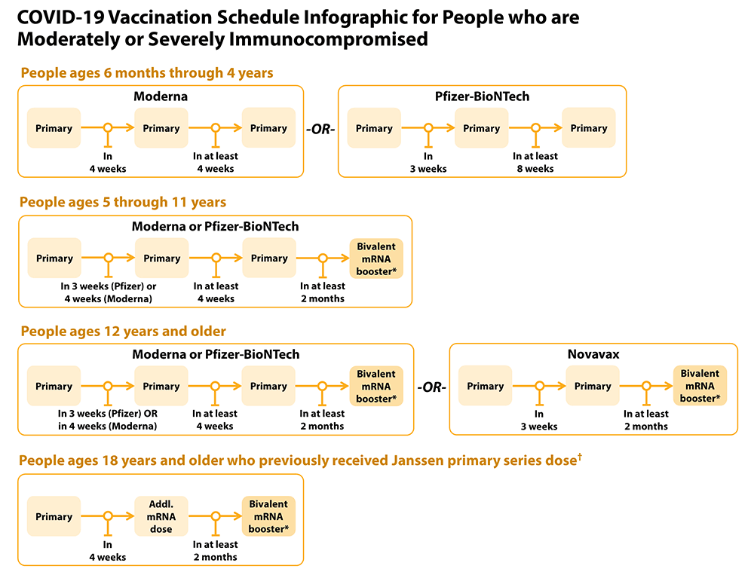

Addressing Barriers to Vaccination
Barrier: Possible Intervention:
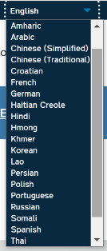
Lack of transportation | - Call your local transit authority for a free ride to your vaccine appointment. You may need to call in advance to schedule a ride.  - Ask your vaccine provider about transportation options
No computer/internet/smart phone | - Call 1-800-232-0233 to connect with someone who can help you schedule a vaccine appointment.
Can’t take time off work to go | - Appointments are available in evenings & on weekends. (Check pharmacies)  - In case you have minor side effects, you may want to get vaccinated before a day off.
No primary care doctor | - You don’t need to have a PCP! Many pharmacies & the LHD are vaccinating  - If you have medical questions, you can call the NC Vaccine Support Line- 877-490- 6642 (7am-11am).
English language limitations | - https://covid19.ncdhhs.gov/vaccines  (Top right corner says “Select Language”)  - Phone # 888-675-4567 (interpreters available)

