INTERVIEW SCRIPT FOR THE CONTACTS OF PERSONS WITH SUSPECTED OR CONFIRMED COVID-19
For Coronavirus Disease 2019 (COVID-19) Contact Tracing
Below is an outline of the steps and information to cover while interviewing someone in contact with a person believed or confirmed to have COVID-19. To ensure you have the best call response, please use the following suggestions to provide you and the contact a comfortable phone environment:
- Always use a warm, welcoming, confident tone of voice. Your tone should reflect a positive smile and pace.
- Be sure to personalize the call so that you sound approachable and friendly and to help build a personal connection with the close contact. In addition, you may add "Good Morning," "Hi," or another welcome phrase to start the call.
- It is important to remember that each close contact is different. Some will be nervous or scared and others may be frustrated and confused.
- Someone may be calling on behalf of a spouse, child, or loved one, so remember to be clear, to repeat and emphasize essential information.
- Help ensure the close contact is comfortable, informed, and can access the resources or support they may need.
- Be positive and supportive. We want to ensure close contacts do not feel as if they did something wrong. Close contacts should know that we are here to make sure they are informed and receive the support, resources, and information they need.
- Acknowledge verification. Use the close contacts name if they are calling on behalf of someone else, acknowledge that and approach the conversation through that lens by repeating information and providing time for them to verify information.
- Share the benefit of this call. It is important to emphasize that the information close contacts are providing or receiving will help protect their family, loved ones and friends/co-workers (if applicable). Be clear about the purpose of the call and what the close contact will receive or gain from being on the call. This may help them understand the purpose of the call, its importance, and the benefits for themselves and/or loved ones.
- Build trust. We are requesting and sharing a lot of information related to the close contact. That may feel uncomfortable and puts your close contact in a vulnerable position. Some close contacts may be skittish about answering certain questions or need a moment to process the information you are providing. It is important that you clearly explain how you are involved with the COVID-19 Community Team, what your role is, and how you will help ensure the close contact and their loved ones receive the resources and support they need to be protected. If you are making an outbound call, the close contact may have questions or concerns about why you are calling or how you received their contact information. Be clear about your role and your purpose for the call.
- Be patient. Some close contacts may be working from home or caring for loved ones. Others may be calling from work. Close contacts may have children in the background or multi-tasking while on the call. Be sure to repeat vital information, check for understanding, and define unfamiliar and medical terms (ex. self-quarantine, symptomatic) to ensure the purpose is understood. Take the time needed to ensure your close contact feels heard and has the understanding they need to protect themselves and their families.

This document provides an outline of the steps and content to cover when interviewing someone believed or confirmed to have close contact to someone with COVID-19. To jump to a particular section, click the hyperlinks below while holding the CTRL key on your keyboard:
Section 1: Preparing for the Interview 2
Section 2: Introducing Yourself and Purpose for the Call 2
Section 3: Symptoms and Medical History 5
Section 4: Guidance for Contacts 5
Section 5: Testing Guidelines 6
Section 6: Needs Assessment for Resources or Support 9
Section 7: Additional Contact and Demographic Information 10
Section 8: Wrapping Up 10
Section 10: Supplemental COVID-19 Vaccine Information 12

Section 1: Preparing for the Interview
Contact Information – interview preparation  - Source case-patient’s NC COVID event #  - Last date the contact was exposed to source case-patient (per case-patient’s report)  - Name and date of birth or reported age  - Residential address  - Employer name and/or location  Close-contact Guidance – ensure you are up to date on guidance for close-contacts after being exposed to COVID-19**  COVID-19 Vaccine Information – ensure you are up to date on COVID-19 vaccine guidance, recommendations, and how to talk to contacts and case patients about barriers and vaccine hesitancies*** | This procedure is done prior to calling the contact. If you identify a duplicate record, follow the job aid procedures.  The case-patient's information is not to be shared with the contact during the call.  *If contact is a minor – Speak first with guardian. See script sections below for “Minors Under 13” and “Minors Above 13, but Under 18.”  **Review current guidance at the following link: What to Do If You Were Exposed to COVID-19 | CDC  and ensure you understand how it applies to your local health department guidance.  ***Review the Supplemental COVID-19 Vaccine Information

Section 2: Introducing Yourself and Purpose for the Call
IF THERE IS A RESPONSE:  “Hello, my name is [insert your name] and I am calling on behalf of the [insert name of local health department] regarding a time-sensitive public health matter. May I speak with [insert contact’s first name]?”  IF THERE IS NO RESPONSE (VOICEMAIL SCRIPT):  “Hello, this is [insert your name] calling for [insert contact’s first name] on behalf of the [insert name of local health department]. We are reaching out about a time-sensitive public health matter and would like to speak with you to provide some further information. Proceed appropriately with an option below.  IF LHD: At your earliest convenience, please give us a call back at the [insert name of local health department] at [insert phone number] or at our statewide call center at (844) 628-7223. Their hours are 8am to 6pm. Again, I am [insert your name] calling on behalf of the [name of local health department] regarding a time-sensitive public health matter. Thank you.”  IF CCTC: At your earliest convenience, please give us a call back through the statewide call center at (844) 628-7223 between 8am to 6pm, and ask for me, [insert your name], at extension [insert ext. number]. Again, the number for the call center is (844) 628-7223, and I am [insert your name] calling on behalf of the [insert name of local health department] regarding a time-sensitive public health matter. Thank you.” | If the person is not the individual you were trying to reach, ask to speak with the correct person. If the number is wrong, apologize for the inconvenience and end the call.
“Could I please confirm, is English your preferred language?”  IF ENGLISH IS CONTACT’S PREFERRED LANGUAGE:  “Thank you. And is this the best phone number to reach you?”*  IF ENGLISH IS NOT THE CONTACT’S PREFERRED LANGUAGE:  “I’d like for you to be able to speak to someone who can allow you to communicate how you’re most comfortable. May I call you back in just a few minutes with someone that can help us with that?”** | *If the contact indicates another preferred phone number, update their CCTO monitoring event appropriately.  **If the contact confirms that English is not their preferred language, continue according to regional or local health department direction.
IF THE CONTACT IS NOT AVAILABLE TO TALK:  “Is there a better time for me to call back?” | The contact might be sleeping, resting, or at work. Wait for a response; thank the person, document, and schedule an outreach for the designated time.
IF THE CONTACT TRIES TO END THE CONVERSATION BY SAYING THEY ARE VACCINATED:  IF contact voluntarily informs you that they have been  vaccinated, thank the contact for sharing and let the contact know you will ask for details about their vaccination status (type, dates, etc.) after gathering some other information.  IF contact questions why they could still be at risk for COVID-19 even though vaccinated, share the information listed to the right. | - Breakthrough infections are much more likely with the new Omicron strain of COVID-19  - Person could have already been incubating virus at time of vaccination.  - Vaccines are highly effective, but a small percentage of individuals do not develop the expected antibody response to vaccines.  - Vaccines may decrease severity of illness without preventing all infections.  Keep in mind this individual may not be fully vaccinated or may be eligible for a booster shot.
IF THE CONTACT IS AVAILABLE:  “Would it be all right if I ask you a few questions? Please know that any information you give me during our conversation is confidential. The same is true for any information that is provided to the local health department.”  “Would you mind verifying your address and date of birth, so I can ensure that I have the right person on the phone, and that the right person’s information is pulled up in my system?”* | *Confirm at least one additional piece of identifying information (example: date of birth, residential street address, place of employment, or last name if there are no other options).  If the contact is reluctant to confirm identity, encourage them to Google the number from which you are calling and see that it is legitimate; to call back to the call center (844-628-7223) between 8am to 6pm and listen to the automated prompt; or (as a last resort) to call the LHD to confirm the call is legitimate. If the contact is ultimately unwilling or unable to confirm their identity, the call cannot continue. Do not mention that you are calling about a COVID-19 exposure unless the identity has been confirmed.
MINORS - UNDER AGE 13:  “Hello, my name is [insert your name] and I am calling on behalf of the [insert name of local health department] regarding a time-sensitive public health matter. May I speak with your legal guardian? | Must speak first to guardian.  Wait for guardian before continuing with call.
MINORS - ABOVE AGE 13, BUT UNDER AGE 18:  IF contact answers: “Since you are under age 18, I will need to speak to your legal guardian first. Would you please put them on the phone?”  IF legal guardian answers: “Hello, my name is [insert your name]. May I speak with [first name of contact]’s legal guardian?  “I have a few questions for your child to help understand their risk of becoming ill and to provide you some information and resources if needed. Would it be okay with you if I spoke with them directly or would you prefer to stay on the line?” | Must speak first to guardian. Ask permission to speak with minor.  Wait for a response. If no guardian is available, ask if there is a better time to call back or a better number.  If the guardian answers the phone, continue with the call.
IF CONTACT IS OUT OF JURISDICTION:  IF contact is an NC resident, follow LHD’s protocol. Complete the interview and assign the contact to the county of residence per the OOJ Job Aid. Tell the contact that we will send their information to their county of residence.  IF contact is not an NC resident, confirm state of residence and collect their address per OOJ Job Aid. Share NC guidance, inform them that someone else may be following up with them, thank them, complete OOJ Job Aid process steps, and end the call.  IF contact is a student, out-of-state worker, or visitor in NC, follow LHD’s protocol. Complete interview. | * Refer to OOJ Job Aid for CCTO process for handling out-of-county and out-of-state contacts.
“I am calling today because we are closely monitoring the spread of COVID-19. We have identified you as having recent contact with someone who has been diagnosed with COVID-19. What thoughts do you have about this news?” | Listen, reflect as appropriate.
IF THE CONTACT REQUESTS THE NAME OF THE CASE-PATIENT:
“Due to medical privacy laws, we are unable to share that information. Any information shared here, including yours, is confidential and will be kept private.”

Section 3: Symptoms and Medical History
“How are you feeling today?”  “Would it be all right if I ask you a few more questions about your symptoms and medical history so we can best determine your risk for becoming ill?”  “Do you currently have any of the following symptoms?”  - Fever - If yes, “What has been your highest measured temperature in the past 24 hours?”  - Sweats  - Chills  - Headache  - Muscle Aches  - Sore Throat  - Cough - If yes, “Has it been productive? Mucus?”  - Loss of smell or taste  - Shortness of breath or difficulty breathing  - Stomach pain or cramps  - Vomiting  - Diarrhea  “When did your symptoms start? MM/DD/YYYY” | Document all contact responses within their CCTO assessment per the job aid. If a referral is necessary, please see the job aid on referrals.  Wait for each response, note each response, then continue with next question.

Section 4: Guidance for Contacts
IF THE CONTACT DOES NOT HAVE SYMPTOMS AND DOES NOT LIVE IN A HIGH-RISK CONGREGATE SETTING: “Quarantine is no longer recommended for people who are exposed to COVID-19 except in certain high-risk congregate settings. Although you may not need to quarantine, you should wear a mask until [insert date based on 10 days since last date of exposure] and get tested on [insert date based on 5 days since last date of exposure]; however, if you do become symptomatic within the 10 days after your last exposure to COVID-19, you will need to immediately self-isolate, get tested, and call us back if you need further assistance. Do you have a face covering at home with you?” See guidance on the right* and testing guidance below.  IF THE CONTACT HAS SYMPTOMS:  “Any contact who has COVID-19 symptoms (regardless of vaccine status or previous infection) should get tested and isolate immediately through at least [insert date based on 5 days since onset of symptoms] or until you have a negative test confirming your symptoms are not caused by COVID-19. If your symptoms are resolving and you have been without a fever for at least 24 hours (off all fever reducing medications), you can leave your house, but you must wear a mask until [insert date based on 10 days since onset of symptoms]. Do you have a face covering at home with you?” See guidance on the right* and testing information below.  IF THE CONTACT LIVES IN A HIGH-RISK CONGREGATE SETTING:  “People who are exposed to COVID-19 and live in high-risk congregate settings such as correctional facilities, homeless shelters, and nursing homes should quarantine. This means that based on the timing of your exposure, you will need to stay quarantine through at least [insert date based on 5 days since last day of exposure] and get tested on this day, if possible. Then, if you are not experiencing symptoms, you can end quarantine, but you must wear a mask until [insert date based on 10 days since last day of exposure]. If you develop symptoms, you should get a test immediately. Do you have a face covering at home with you?”  “I would like to ask you some questions now to better understand what support you might need. Would that be okay?” Pause for response. | *Please check these links often to make sure you are up to date on guidance and ensure understanding of local health department guidance.  Provide most recent guidance based on the current CDC and NC DHHS guidance at the following links: https://www.cdc.gov/coronavirus/2019-ncov/your-health/quarantine-isolation.html  School associated contacts  If you know or expect that the individual is a student or staff member at a school, you can inform them that they may be able to continue going to school in person while wearing a mask. You should encourage them to talk to their school to find out specific details about this.  A contact may ask for details on the date of their exposure. In some situations, there is a significant delay between date of exposure and date of notification. The contact may express frustration at this delay. If this happens, you should express that you empathize with the contact, but that this situation can be a result of numerous factors outside of our control and are not uncommon. For example, in many cases, the person who tested positive may not get tested right away which could lead to a delay, especially if the exposure took place at the beginning of their contagious period. Additionally, the test may take a couple of days for a result. As the process for determining close contacts can only begin once a case patient’s lab result is reported, the date of notification may be many days after the date the exposure occurred.
“Do you have a face covering at home with you?”  “Can you tell me about your living situation?”  “What are your plans if you become seriously ill?” | Wait for each response, reflect, and document.

Section 5: Testing Guidelines
“I am curious; have you been tested for COVID-19?” | Make sure to update all testing information in the testing section of CCTO. Listen and respond appropriately questions or comments.
IF THE CONTACT HAS NOT BEEN TESTED:  “Since you have not yet been tested, may I share some information with you about getting tested?”*  “It is recommended that you get tested no earlier than [insert date based on 5 days since last day of exposure], unless you’re experiencing symptoms.”  “Someone who has COVID-19 can have no symptoms or mild symptoms but still spread the disease, so it’s important to be tested even if you feel fine. What questions do you have about the information I am sharing?”  “If you have trouble scheduling a test without showing symptoms, inform the testing site that you have been named as a close contact by the [insert name of local health department]. If your primary care provider does not provide testing, the North Carolina Department of Health and Human Services has a link on their website to help you find a free testing site near you titled “Find My Testing Place.”  IF an at-home collection test is appropriate: “If you don’t feel that you can get to a testing site at this time, I can also help you with ordering an at-home collection test free of charge online that will be processed through the mail. Would you be interested in that?”  IF not open to hearing information, “Is there any other information you would like?” | *Refer to CDC guidance for up-to-date information, and remind contacts to wear a mask to the testing site or facility. Make sure to follow-up with contact to determine if testing occurred.  Support Resources for Contacts:  - https://covid19.ncdhhs.gov/about-covid-19/testing Find My Testing Place  - https://www.pixel.labcorp.com/nc Pixel At-Home Testing Kit Link  See this job aid for helping contacts order Pixel at-home testing kits.
IF THE CONTACT HAS BEEN TESTED*:  - “When were you tested?”  - “Was your test negative or positive?”  - IF negative: “A negative result means you are not showing evidence of COVID-19 at this time. If you took at at-home test and tested negative, consider testing again 1 to 2 days after your first test. Even if you test negative, you could still become ill until you are outside of the 10-day incubation period for the virus. That date for you is [insert date based on 10 days since last day of exposure], and you will still be asked to wear a mask around others until this date.”  - IF positive: “A positive result means that you are infected with the COVID-19 virus and will need to remain in isolation for at least 5 days since your symptoms first began or since you were tested for COVID-19 if you have no symptoms. This means that you will need to stay in your home and away from others in your household until you are no longer considered to be contagious. Isolation for 5 days followed by wearing a well-fitting mask for an additional 5 days will minimize the risk of spreading the virus to others. You are considered non-contagious when it has been at least 10 days since your symptoms started or you tested positive (if you have no symptoms), it has been at least 24 hours since you have had a fever, and your other symptoms have improved. Most individuals with COVID-19 have no or only mild symptoms of illness and recover without the need for medical care.” Pause for response.  “Also, since your test was positive, someone else may call you on behalf of the from the [insert name of local health department] to provide you with additional guidance. The person who calls may work with you to identify any friends, family, or co-workers who need to be notified of their exposure so that we can slow the spread of the virus and make sure that we can support anyone who might need extra resources at this time. In the meantime, you should notify anybody who you have been in close contact with (within 6 feet for more than 15min cumulatively within 24 hours) about their potential exposure. If you don’t feel comfortable reaching out directly, I can offer you a website that will help you notify your contacts anonymously. You may receive a text message or email that goes over this information.”** | *If the contact has been tested, need to confirm that the test was conducted in the appropriate window (at least 5 days after the last exposure).  Make sure to update all testing information in the testing section of CCTO.  **Refer to this website to inform close contacts about the exposure: https://tellyourcontacts.org/
IF THE CONTACT REFUSES TESTING:  “[Insert contact’s first name], only you can decide if testing is the best thing for you, but it is highly recommended. It is critical that you continue to monitor yourself for symptoms and let the health department know if there are any changes.”  “Do you have any questions about what to do if you develop symptoms or decide to be tested?”  IF NO: “If you begin showing symptoms, we encourage you to visit a testing site or your primary care provider/family physician. Inform the facility that you have been exposed to COVID-19, you are experiencing symptoms, and the local health department has recommended you for testing.”  IF YES: Review and use opportunity to educate contact. | Reiterate the importance of self-monitoring for symptoms and letting the health department know if there are any changes or developments in their symptoms.  Remind contacts that they will need to wear a mask to the testing site or facility if they decide to get tested.

Section 6: Needs Assessment for Resources or Support
“Next, if it is all right with you, I would like to ask you a series of questions about what kind of resources you might need if you do become ill, or how we may be able to assist you.”* | *IF YES: Continue to share information. Pause at intervals to confirm, “Does that make sense?” or “Do you have any questions about what I just said?”
“Would it be okay if I asked you some questions about your medical history to see if you are at a higher risk of becoming sick from COVID-19?”*  “May I share with you some things others thought were helpful?” | *Examples of medical conditions to consider may include: age >64yrs, chronic medical conditions, immunosuppressed conditions, etc. Document in Notes section of CCTO as appropriate.  If a work note is needed, follow local protocol for getting this to the contact.
ADDITIONAL QUESTIONS FOR CCTO ASSESSMENT:  - “Do you have access to a phone or the internet?”  - “Do you have any household members who are high risk for becoming severely ill if they acquire COVID-19?”  - “Do you have someone who can bring you food and supplies if needed?”  - “Do you have a primary care provider?”  - “Are there any other resources that you need  IF THE CONTACT IDENTIFIES A RESOURCE NEED THAT YOU CANNOT MEET IMMEDIATELY:  “Thank you for sharing that with me. I would like to make sure you have the resources you need to stay safe and healthy. Would it be okay for someone from [insert local health department] to follow up with you within the next 24 hours?” | Document all relevant contact responses within their CCTO assessment per the job aid. If a referral is necessary, please see the job aid on referrals.  ** This may be the only chance some people have to get out of a situation such as domestic abuse.  If contact identifies resource needs that you can help resolve without needing to refer to the local health department (i.e., referral to 2-1-1 or NCCARE360), do so and document the resolution in the Notes section in the CCTO Referral tab.  NC Department of Health and Human Services- For COVID-19 questions call 1-888-675-4567  NC Vaccine Support Line- 877-490-6642 (7am-11am) (Can also speak to a Physician if they have medical questions and no insurance.)  View this link for a list of CHWs assigned to most counties.

Section 7: Additional Contact and Demographic Information
“At this point, may I gather some general information from you that will help us understand the people and communities being affected the most by the COVID-19 pandemic?”  “May I ask how you identify your sex, race, and ethnicity?”*  “Could you please verify your home address and county?”*  “Thank you for verifying your information! During this time, we might need to stay in contact with you. What would be your preferred method for us to do so?”* | Allow the contact to respond; answer accordingly.  * Contact may refuse, try to at least verify town and county. Be sure to document demographic information, address, and preferred method of contact within CCTO.

Section 8: Wrapping Up
“What other questions can I answer for you now?”  “If you develop any severe symptoms, such as a consistent fever above 102˚ Fahrenheit, difficulty breathing or chest pains, new confusion, inability to wake or stay awake, or bluish lips or face please call your medical provider or 911 so that they can provide immediate and appropriate care.”  “In order for me to provide you with the current vaccine guidelines and help keep you and your community safe, I’m curious – have you received the COVID-19 vaccine?”  IF VACCINATED*  “Since you’ve been vaccinated, can you provide me with the dates you received each dose, and what type of vaccine?  "Are there any questions I can answer or resources I can provide you to help the people around you who might not have been vaccinated yet?  “A couple final things. Have you received the updated booster shot? You can find details on whether you are up to date on COVID-19 vaccines and boosters at the CDC website (see right), or you can also reach out to a healthcare provider or the Vaccines Call Center (888-675-4567) for any questions or concerns you may have regarding booster shots.”  IF NOT VACCINATED**:  “Before we get off the phone, we at the [insert name of local health department] do want to reach out and let everyone in our area know that the COVID-19 vaccine is free, safe, and available to anyone who would like to receive it. I’m curious; what are your thoughts on the vaccine(s)?” Pause for response. Refer to Supplemental COVID-19 Vaccine Information.  CLOSING THE CALL:  “If you think of any questions after this call has ended, you can contact the [insert name of local health department] at [insert the LHD’s phone number] or the NC COVID Community Team Call Center at (844-628-7223) between 8am to 6pm. My extension is [insert your extension], and once again, my name is [insert your name].”  “Thank you for your time today and for answering my questions. We are here to help, so please do not hesitate to reach out with any questions during this challenging time.” | Allow the contact to respond; answer accordingly.  Have the contact repeat the symptoms you have listed and need to monitor.  *Vaccine referrals should be documented (per the Referrals job aid) for every case and contact who is monitored in CCTO, even if they are fully vaccinated or decline the referral. Vaccinated individuals may also be interested in offering resources to others in their family or community and therefore may be interested in the referral or in receiving further vaccine communications.  If contact has been vaccinated, enter the information in the vaccination section of CCTO.  CDC website on booster shot information: https://www.cdc.gov/coronavirus/2019-ncov/vaccines/booster-shot.html  CDC guidelines now allow for “mix and match” dosing of booster shots, meaning that individuals may choose which vaccine they receive as a booster shot, regardless of what was previously received. If the contact asks you about this, please tell them to speak with their provider. More information can be found here: https://www.cdc.gov/coronavirus/2019-ncov/vaccines/stay-up-to-date.html  **If they have not been vaccinated, listen and reflect on their response. If they are willing to discuss more with you, continue to the Supplemental COVID-19 Vaccine Information when you finish your conversation.

Section 9: Supplemental COVID-19 Vaccine Information
To make sure you have the most up to date CDC information and guidance regarding the COVID-19 vaccine, please refer to the following websites:
- Stay Up to Date with Vaccines
- How to talk about COVID-19 Vaccines
- Understanding how COVID-19 Vaccines Work
- CDC's Myths and Facts about COVID-19 Vaccines

Additional Resources
- Booster Tool (Find out when you or your loved one is due for their next shot!)
- Frequently Asked Questions about COVID-19 vaccines
- COVID-19 Data Tracker
- Chat online with a robot that can answer your COVID-19 vaccine questions
- To find vaccines near you, you can:
    - Visit myspot.nc.gov
    - Call 1-800-232-0233
    - Text your zip code to 438829

Basic COVID Vaccine Info
- There are four recommended COVID-19 vaccines in the U.S today
- The COVID-19 vaccine is free, safe, effective and recommended for everyone over 6 months old.
- Getting vaccinated is the best way for us to get back to normal and keep our community safe from severe illness/hospitalization due to COVID-19.

Have you received any COVID-19 vaccines so far?

Yes
No

That is not a problem. I respect your decision and am not here to push you at all. There can be a lot of different reasons why people are hesitant to get the vaccine. It is helpful for your Local Health Department to be aware of those different reasons, so that we can better understand our community. Would you feel comfortable telling me a little about your own reasons? I am here to listen, try to understand, and only offer information if you want it.

That is great news, thank you for letting me know! We will update our records to reflect the vaccines you have received and make sure that you are up to date with current recommendations.
Do you feel comfortable telling me a little more about the vaccines you have received and when, so I can update our records as well as learn if you are up-to-date?

Yes
Yes
No
Thank you for being willing to talk more with me about this. Which vaccine did you receive and when did you receive it? I can wait if you need to go get your vaccination card.
Vaccine Schedule for Non-immunocompromised Individuals
Vaccine Schedule for Immunocompromised Individuals

B

Thank you for being willing to talk more with me about this. Can you tell me more about your reasons to not get vaccinated?

That’s alright. I appreciate your time. If you do have any other questions later about the COVID-19 vaccines, feel free to call a health care provider you trust or your local health department.

Click below to find talking points on common vaccine hesitancy reasons:
- Cost  - Don’t need it (I’m healthy/ just had COVID)  - Don’t need it (nobody gets COVID anymore)  - Microchip/No govt. trust  - Safe for kids? | - Came out too fast (is it safe?)  - Does it work?  - I don’t know/something else  - Side effects  - Immunocompromised  - Pregnant/ Breastfeeding/ Fertility

Click if questioning whether to get a booster

Vaccine Hesitancy and Confidence Building Conversations
One of the primary vaccine barriers is vaccine hesitancy, a personal choice to delay or refuse getting vaccinated. When talking to contacts and cases, it may be helpful to understand some common reasons for hesitancy and how to engage in dialogue with those individuals. Some identified reasons and possible responses are listed below.

I’m worried about the cost of the vaccine.

- The COVID-19 vaccine is free for everyone! No proof of insurance or ID is required to receive the vaccine (NC DHHS).

I don’t think I need the COVID-19 vaccine. (Either) I’m young and healthy (or) I just recently had COVID-19 so now I have natural immunity, right?

- The Omicron variant is very contagious; anyone is susceptible to contracting the virus and possibly having symptoms. The virus can be spread by asymptomatic individuals (CDC).
- Re-infection can happen and new variants of the virus continue to be discovered (CDC).
- Individuals who have previously had COVID-19 infection are less likely to become reinfected if they are fully vaccinated (CDC).

I’m worried about the side effects of the vaccine.

- Some patients do experience mild side effects after receiving the vaccine. However, the possible side-effects are minor in comparison to the chance of you, or a loved one, contracting COVID-19 and becoming seriously ill (CDC)
- Side-effects do not include contracting COVID-19 or other serious health conditions (CDC)
- Research indicates that getting the vaccine is the best way to protect yourself from serious side effects, hospitalization and death due to COVID-19 (CDC)

I have a health condition and am concerned about my safety.

- If you have concerns about a specific health condition, you should consult your doctor.
- Individuals with moderate or severe immunocompromising medical conditions are at increased risk of becoming seriously ill or even dying from COVID-19, so getting vaccinated is especially important for these individuals (CDC).
- You can self-attest to your moderate or severe immunocompromised status. There is no paper documentation needed to receive a vaccine or booster (CDC).

No one is really getting COVID-19 anymore, so I don’t need the vaccine.
- People are still contracting COVID-19 across the state and country (CDC)
- The Omicron variant is even more contagious than the Delta variant (CDC)
- People that are unvaccinated account for the majority of hospitalizations and deaths due to COVID-19 (CDC)

I don’t want a microchip implanted in me. (or) I don’t trust the government.

- The COVID-19 vaccine doesn't contain any technology including microchips or software. All vaccine ingredients are publicly listed on the FDA and CDC websites. (CDC)
- The COVID-19 vaccines were not developed by the government, but rather by private companies with long-standing reputations for providing safe and effective vaccines. (CDC)

The vaccine was developed so quickly. I want to wait and see if it’s safe.

- The quick development of the vaccine was not due to any corner-cutting and followed the standard FDA approval process as every vaccine before (CDC).
- More than 619 million people have received a COVID-19 vaccine (CDC)
- Researchers had previously been studying coronaviruses for years and were able to get a head start in the development based on that research (CDC)
- To make sure the vaccine is safe, CDC expanded and strengthened its ability to monitor vaccine safety (CDC)

I am pregnant, breastfeeding or thinking of becoming pregnant in the near future and I have concerns about how the vaccine may affect me and/or my child.

- The vaccine is recommended for people who are pregnant, breastfeeding, or trying to get pregnant in the future. (CDC)
- People who get COVID during pregnancy are more likely to get very sick or have complications (CDC)
- Studies show that COVID-19 vaccination did not affect women’s likelihood to get pregnant (PubMed) or increase the risk of miscarriage (when vaccinated before 20 weeks) (CDC)
- If you would like to speak with someone about COVID-19 vaccination during pregnancy or breastfeeding, you can contact MotherToBaby, whose experts are available to answer questions in English or Spanish by phone or chat. Call 1-866-626-6847 M-F, 8-5pm or go online to https://mothertobaby.org/contact/

- Vaccines for children are safe and effective. (CDC)
- Why Children And Teens Should Get Vaccinated (CDC)
- Children receive a smaller dose of the vaccine than teens or adults (CDC).
- Millions of Americans ages 5-17 have received the COVID-19 vaccine (American Academy of Pediatrics)
- 6 Things to Know About COVID Vaccination for Children (CDC)

Getting the vaccine for myself is one thing. Vaccinating my child is another thing. I’m too scared to risk it.

I don’t think the vaccine works.

- Unvaccinated adults were 5.3x more likely to be hospitalized due to COVID-19 than their up-to-date, vaccinated counterparts. (CDC)
- The COVID-19 vaccine has proven to be highly effective, cutting down on infection and hospitalization (CDC)

I don’t know why I don’t want to (or) it’s something else.

It’s okay. Your opinions are valid and at the end of the day, it is your decision whether or not to be vaccinated. I am here to support you. Do you have any questions for me?
Would it be alright with you if I share a little bit of information about the vaccine?
If yes, click here for basic information about the COVID-19 vaccine
If no, Thank you for your time and if you have any other questions you can call your local health department or health care provider.

I got my primary series but I am not up-to-date on all my boosters. Does it really matter?
That is great that you received the primary series of the COVID-19 vaccine! That will provide you some protection. However, the CDC recommends that everyone over the age of 5 receive the bivalent booster which helps protect against the Omicron variant specifically. Similar to the flu vaccine, it is important to receive regular booster shots because immunity wears off with time and new variants emerge that might not be as protected by a previous vaccine. Does that make sense?
Would you like to learn how to schedule your booster today?
If yes, click here
If no, thanks for your time. You can always call or go online later if you decide you want to.
Offer to give info if they want it:
1.) Visit myspot.nc.gov 2.) Call 1-800-232-0233 or 3.) Text zip code to 438829

Vaccine Schedule For People Who Are Not Immunocompromised
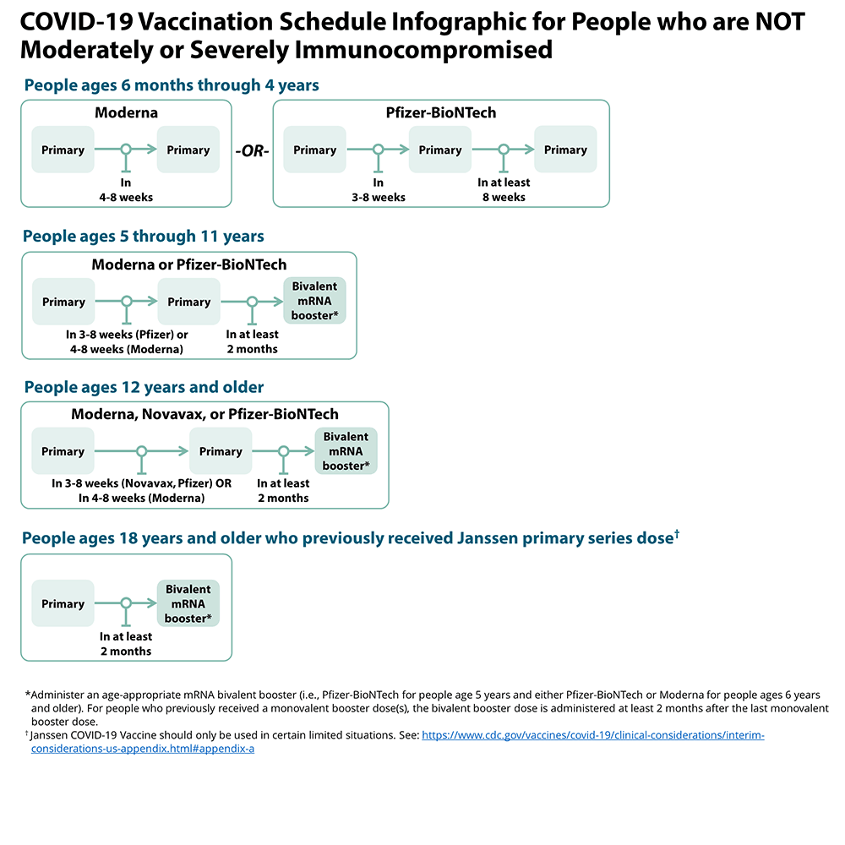

Vaccine Schedule For People Who Are Immunocompromised
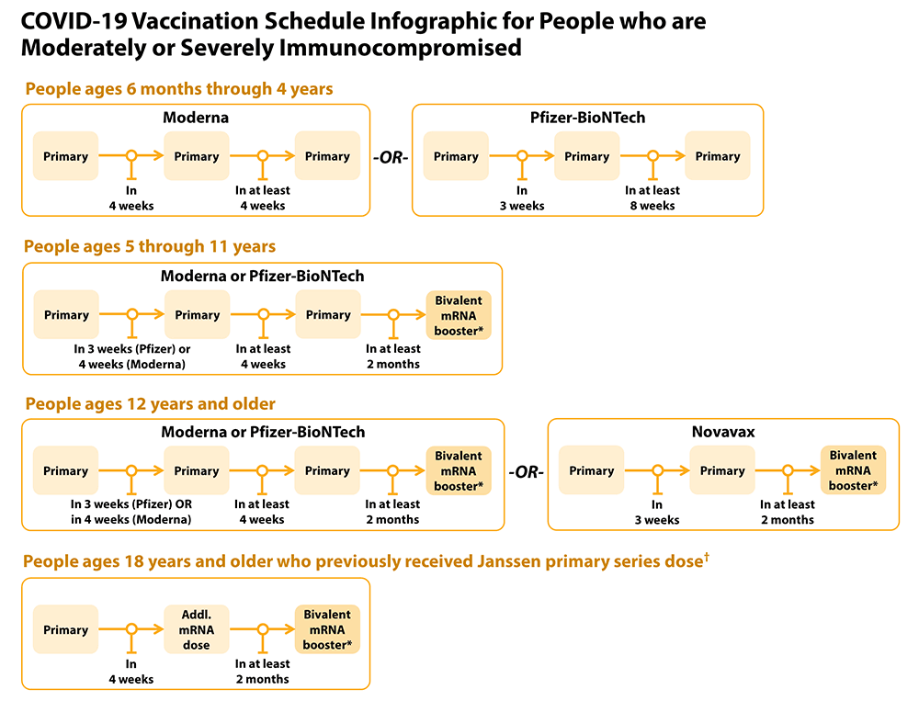

Addressing Barriers to Vaccination
Barrier: Possible Intervention:
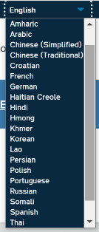
Lack of transportation | - Call your local transit authority for a free ride to your vaccine appointment. You may need to call in advance to schedule a ride.  - Ask your vaccine provider about transportation options
No computer/internet/smart phone | - Call 1-800-232-0233 to connect with someone who can help you schedule a vaccine appointment.
Can’t take time off work to go | - Appointments are available in evenings & on weekends. (Check pharmacies)  - In case you have minor side effects, you may want to get vaccinated before a day off.
No primary care doctor | - You don’t need to have a PCP! Many pharmacies & the LHD are vaccinating  - If you have medical questions, you can call the NC Vaccine Support Line- 877-490- 6642 (7am-11am).
English language limitations | - https://covid19.ncdhhs.gov/vaccines  (Top right corner says “Select Language”)  - Phone # 888-675-4567 (interpreters available)

